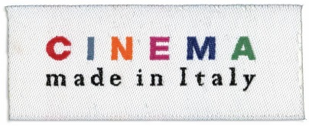

Powered by Deutchman Company

Presents
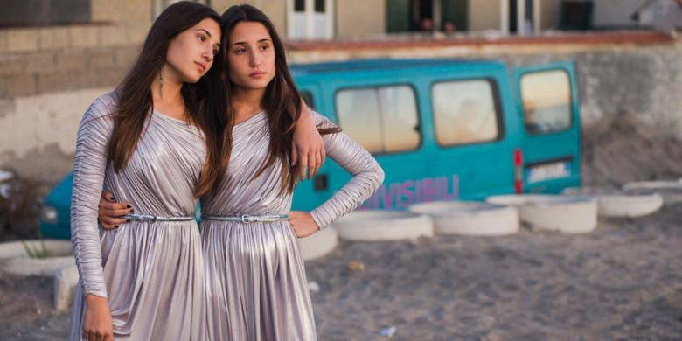
a film by Edoardo De Angelis
**OFFICIAL SELECTION – Venice Film Festival**
**OFFICIAL SELECTION – Toronto International Film Festival**

US RELEASE DATE: SEPTEMBER 15, 2017
RUN TIME: 100 Minutes

Media Contacts:
Cinetic Marketing
Ryan Werner, ryan@cineticmedia.com
Ted Geoghegan, tedg@cineticmedia.com

SYNOPSIS
Daisy and Viola are conjoined twin sisters living in the suburbs of Naples. They are blessed with beautiful voices and, thanks to their performances at local weddings, communions and baptisms, have become the breadwinners for their entire family. Kept isolated from the world by their exploitative father, their lives are turned upside down when one of them falls in love for the first time…and they discover that it is possible for them to be separated.

DIRECTOR’S NOTES
This is a film about separation and about how painful it is.

I’ve been focusing on the idea that, sometimes, to grow up, you need to feel pain, you need to give up a part of yourself.

I’ve been looking for an image that could represent this concept at its best and finally I found it: two conjoined sisters, on the verge of turning 18, who suddenly find out that they can be separated. Two girls attached by their hip, extremely beautiful and at the same time unsettling. I’ve tried to balance attraction and repulsion in each frame I have built for the film.

I see the world like this: always on the edge between beauty and ugliness. Being always on this edge, brought me again to Castelvolturno. I was there already, in fact this film starts where my previous one ended, on the right shore of the Volturno river. That territory is the heart wrenching simulacrum of a lost beauty, a perfect place where I could set the cage from which my two “sweet birds” desperately want to escape. Their dream is a normal life: they want to have an ice cream, go dancing, drink some wine without fearing that the other would get drunk…make love. Because they’re women.

Edoardo De Angelis

FESTIVALS AND AWARDS
David di Donatello Awards
Winner – Best Original Screenplay
Winner – Best Supporting Actress
Winner – Best Producers
Winner – Best Costume Design
Winner – Best Music Composer
Winner – Best Original Song
Venice Days – Venice Film Festival
Official Competition
Toronto International Film Festival
Contemporary World Cinema
BFI – London Film Festival
Love
Festival du Film Italien de Villerupt
Official Competition
Rencontres du Cinema Italien Toulouse
Official Competition
Kerala International Film Festival
World Cinema Section
Cinema Italian Style Los Angeles
Cinema Italian Style Seattle
Les Arcs European Film Festival
Official Competition
Palm Springs International Film Festival
World Cinema Now
Victoria Film Festival
Official Competition
Santa Barbara International Film Festival
Cinematic Ouvertures
Vancouver Italian Film Festival
Festival International du Film d’Amour de Mons
Panorama du cinéma Italien
Terra di Cinema Festival Cinema Italien Tremblay
Official Competition
Scottish Italian Film Festival
Bengaluru International Film Festival
Cinema of the Wolrd
Portland International Film Festival
New Directors
Festival Univerciné Nantes
Wisconsin Film Festival
New International Cinema
Murcia International Film Festival
Feature Film Official Selection
Festival Cine Mediterranée Tetouan
Official Competition – Winner Best Film
8 ½ Festa Do Cinema Italiano Lisbon
San Diego Italian Film Festival
Italian Film Series
Cyprus Film Days – International Film Festival
Official Competition
EDOARDO DE ANGELIS
Called by Serbian maestro Emir Kusturica a "visionary talent", Edoardo De Angelis is a director and screenwriter born in Naples in 1978. He graduated in directing at "Centro Sperimentale di Cinematografia" in Rome.
Since 2000 he has won several awards in International film Festivals with his shorts and documentaries. His feature debut is the comedy "Mozzarella Stories" (2011) produced by Bavaria Media and CSC Production, with Emir Kusturica as executive producer.
In 2014 Edoardo wrote and directed his second feature, "Perez.", presented Out Of Competition at the Venice Film Festival. The thriller/drama, produced by O'Groove and Zocotoco and distributed in Italy by Medusa, won three Silver Ribbons (the Italian film critics' awards).
"Indivisible," produced by Tramp Limited and O'Groove, is Edoardo's third feature.

Filmography
Short film
2000 Okappa e Kappao
2001 Lo Scambio
2002 Mors Tua
2005 Tropical Snack
2004 Quanta donna vuoi
2008 Mistero e passione di Gino Pacino
2009 Fisico da spiaggia
Feature film
2011 Mozzarella Stories
2014 Perez
2016 Indivisibili
MAIN CAST
ANGELA E MARIANNA FONTANA
Angela and Marianna Fontana were born in Casapesenna 19 years ago, just a few moments one from the other. Angela (Viola) has glanced the world first, probably hesitating on its threshold, preferring instinctively to leave to her sister Marianna (Dasy) to be born first. Angela and Marianna grew up together, as two Siamese twins in their soul, learning how to sing, how to command other people’s respect, how to be beautiful. Just a few close friends, no boyfriends. Two special girls, pure and honest as well as smart and resolute. Angela and Marianna come from the same small town of frightening Camorra bosses but they’re stronger than them: they’re free.

ANTONIA TRUPPO
Antonia Truppo is an Italian theatre, cinema and television actress. She was born and raised in Naples where she develops her passion for playing since she is very young. She studies acting at the Accademia d’Arte Drammatica in Naples then moves to Rome to work as a professional. In 2001 her cinema debut is in the feature “Luna Rossa” by Antonio Capuano, screened at the Venice Film Festival. Then she goes back to the theatre where she is leading actress in classic plays by some of the most important world theatre authors such as Molière and Luigi Pirandello, winning several awards in her career. Recently switching back to the cinema, Antonia has been awarded with the David di Donatello (Italian Academy Award) for They Call Me Jeeg by Gabriele Mainetti, as best supporting actress.

MASSIMILIANO ROSSI
He graduates in Law and becomes a lawyer but his passion is the theatre. He starts playing in Naples and works with important Italian theatre directors such as Yves Lebreton, Lorenzo Salveti, Renato Carpentieri, Marise Flach, Peter Clough, Anna Redi. In 2008 he directs his first play with “Giochi di famiglia” by Serbian writer Biljana Srbljanovic. His career in cinema starts with “Il resto di niente – The Rest of Nothing” by Antonietta de Lillo (2004) and continues with several other titles: “Fuoco su di me – Fire at My Heart” by Lamberto Lambertini (2006); “Giallo” by Antonio Capuano (2007); “Mozzarella Stories” by Edoardo De Angelis (2010), “I Milionari” by Alessandro Piva (2013), “L’Evento” by Lorenzo D’Amelio (2013), “Tre Tocchi” by Marco Risi (2013), “Indivisibili” di Edoardo de Angelis. In 2013 he’s in the cast of “Gomorrah” the series produced by Sky.

CAST
Viola |  | ANGELA FONTANA
Dasy |  | MARIANNA FONTANA
Titti |  | ANTONIA TRUPPO
Peppe |  | MASSIMILIANO ROSSI
and with
TONY LAUDADIO as Nunzio
MARCO MARIO DE NOTARIS as Uncle Nando
GAETANO BRUNO as Marco Ferreri
GIANFRANCO GALLO as Don Salvatore
PEPPE SERVILLO as Professor Fasano

CREW
Director |  | EDOARDO DE ANGELIS
Story |  | NICOLA GUAGLIANONE
Screenplay |  | NICOLA GUAGLIANONE  BARBARA PETRONIO  EDOARDO DE ANGELIS
Cinematography |  | FERRAN PAREDES RUBIO
Original Score |  | ENZO AVITABILE
Costumes |  | MASSIMO CANTINI PARRINI
Production Designer |  | CARMINE GUARINO
Editing |  | CHIARA GRIZIOTTI
Sound |  | VALENTINO GIANNÌ
Production Manager |  | CAMILLA FAVA DEL PIANO
Executive Producer |  | LINDA VIANELLO
Produced by |  | ATTILIO DE RAZZA E PIERPAOLO VERGA
Production Company |  | TRAMP LIMITED and O’ GROOVE
In collaboration with |  | MEDUSA FILM
In collaboration with |  | MEDIASET PREMIUM
Italian Distribution |  | MEDUSA
International Press Office |  | Magali Montet
International Sales |  | True Colours
Running Time |  | 100’

